DRAFT BUSINESS PLAN

For
Aussie Pooch Mobile

(Revision 2.6)
November 2022

This business plan is to be completed by the prospective franchisee and returned to the support office prior to Aussie Pooch Mobile granting a franchise.

Table of Contents

Executive Summary 3
Objectives 5
Service and Benefits 6
Marketing Strategy 7
Pricing and Profitability 8
Financial Projections 9
Projected Income 10
Executive Summary 10

Executive Summary
I first found out about Aussie Pooch Mobile____________________________________________
I became more interested in Aussie Pooch Mobile after reading all the information that was given to me and also after I spent a day out on the road with an Aussie Pooch Mobile Franchisee.
The Aussie Pooch Mobile seems a perfect opportunity for me, as I love working with dogs, being my own boss, and working outdoors, knowing that you have back up support from the company.
I have had dogs since early childhood and I understand how hard it is to keep a pet clean and healthy. I love dogs and I really enjoy looking after pets. Aussie Pooch Mobile provides a fast, easy and economical way of providing the best possible care for pets.

I believe I have the knowledge and understanding of what it requires to love and care for pets and the understanding of what pet owners require. I also believe that with the support that the Aussie Pooch Mobile offers its franchisee's that I can make my business successful and I will be an asset to the Aussie Pooch Mobile team.

Present Situation
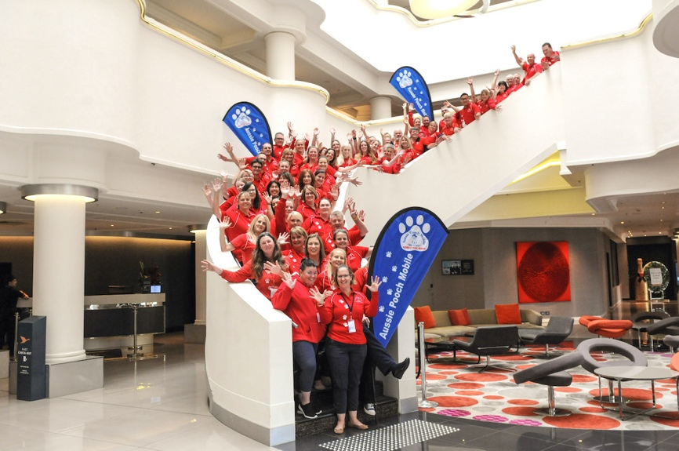

Commencing in Australia in 1991 Aussie Pooch Mobile were the World’s 1st and premier dog wash and care franchise and continue to be the market leaders.
The Aussie Pooch Mobile currently has almost 200 units travelling throughout Australia, washing and caring for over 20,000 dogs per month and growing.
There are five full time staff and 4 part-time staff at the Support office in Brisbane and one full time Recruitment Manager in NSW. Further support is provided by franchise support managers within the field.

Market Environment
The marketplace continues to grow as dog owners increasingly see the benefits to dog ownership and the importance of their care and wellbeing whatever their profession. The Aussie Pooch Mobile is a household name that provides a service that is caring, affordable, reliable and efficient.

Products and Services
The Aussie Pooch Mobile provides a ‘to your door’ dog washing, grooming, clipping, retail sales and advice service for all dogs’ needs.
The Aussie Pooch Mobile standard service includes:
- Hydrobath - A massaging bath for dogs, in warm fresh water
- Brushing - To remove light matting and excess hair from the dog
- Nail Clipping - To ensure that the dog’s feet are kept in great shape
- Ear and Eye Clean -Hygienically cleaned to remove any build-up of ear wax and sleep
- Aromacare - A delightful range of essential oil rinses for use on the dogs
- Blow Drying - All dogs are blow-dried with a warm blow dryer to ensure they are ready to cuddle
- Doggy Treat – A healthy pooch treat is provided at the end of each service
The solutions used to actually wash the dogs are environmentally friendly which include Aromatherapy rinses to further enhance the dog’s best wellbeing. The shampoos used in the service are exclusive to Aussie Pooch Mobile.
Additional services are available which add profits to the business. An example of these are an easy shed service, grooming, clipping, massage, tick wash, medicated washes, facials and aromatherapy.
Retail Profits: New products and solutions are being designed to further enhance the ability to benefit the dogs, build the Aussie Pooch brand and the franchisees' profitability. E.g. Aussie Pooch exclusive treats and various deodorants to be used in between baths just to name a couple.

Pricing and Profitability
Current prices are holding and profits are increasing because of the ability to bathe more dogs in a smaller area as the service becomes better known as well as the ability to provide additional services, such as clipping and retail sales all on a regular basis for the customer’s and dog’s convenience.

Customers
Aussie Pooch Mobile is a ‘Repeat Business’. A large percentage of current customers have their dogs washed approximately two to four weeks to maintain their dogs’ best well being. The services to the customers can be enhanced with further services such as retail sales and grooming and clipping for the dogs. Approximately 75% of the customers are women who are looking to take care of their valued family member.

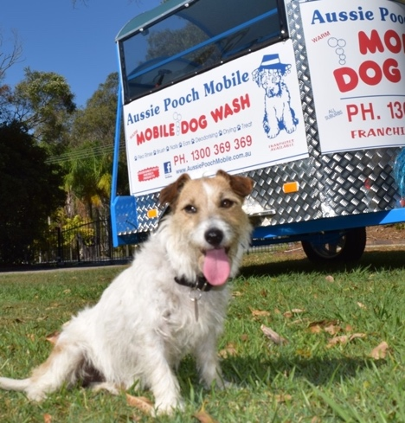

Objectives

My primary objectives are to:
- Be known and appreciated by all dog owners throughout my exclusive territory.
- I expect a good return on my investment that will continue to grow with continual market growth.
- To own my own franchise outright and to use it as a financial basis to purchase another trailer for the exclusive territory that would be operated by a subcontractor.
- Enhance the business within my exclusive territory by offering the customer retail items, grooming and clipping.

Business Goals
- Customer satisfaction
- Quality service
- Reliability
- Affordability
- Growth

Rationale
On the basis of my experience with the company, I feel that:
- The customer is the most important person in any business. The Aussie Pooch Mobile is customer based and offers the service best fitted to the customers' requirements.
- The Aussie Pooch Mobile’s managers come from environments where they are experienced with working with animals to produce an income and return a high profit growth, to managing a large organisation with a rapid growth high-tech development team. I believe that this experience and knowledge will help me to achieve my objectives.

My Objectives are:
- Appropriate... They "ring true" for what I expect to be doing.
- Acceptable... Within industry and political environments.
- Feasible... Achievable given my resources.
- Measurable over time... Number of years.
- Motivating... Aggressive, yet achievable.

Service and Benefits
The service is extremely affordable, requiring a minimal fee per visit to have your dog maintained. This allows customers to utilise its services at regular intervals without costing them a fortune. For example: One of the Aussie Pooch Service features is its ability to be affordable to dog owners regardless of income. E.g. The average price of a fortnightly standard service is approximately $40-$50 per service.
Environmentally friendly products are another powerful feature. This ensures that the dog and anyone coming in contact with it will not be harmed by hazardous chemicals. One very strong capability is the product's ability to help with fleas and clean the dog's coat.
In addition, the use of the hydrobath does not require a tremendous amount of effort on our behalf to ensure that the product reaches the dogs skin through even the thickest coat.
Hydrobathing saves a tremendous amount of water and saves time, compared to traditional bathing methods. With the utilisation of a hydrobath it makes it easy and convenient to bath dogs in colder weather as the hydrobaths have built in heaters, as well as the dogs being blow dried. This also benefits dogs with arthritis or racing dogs that need regular massaging.
Compared to traditional bathing methods, The Aussie Pooch Mobile methods saves time and water (only using 20L per dog). The hydrobathing system and our proven products also help with many skin disorders and coat conditions.

Key Benefits of All Services
The clients and dog’s will benefit from a ‘to your door service’ offering to maintain and achieve a pets best well being. The service is convenient, affordable, reliable and efficient, helping to enhance the benefits of dog ownership.
The combination of all services for the dog are improved appearance, overall health improvement, happy and of course a clean dog. This will ensure the dog continues to provide the benefits of pet ownership to its ‘Pet Parent’.

Service Life Cycle
The average life cycle of a dog is approximately 12 years. A large percentage of customers have their dogs bathed every two to four weeks. This allows for approximately 250 baths per dog per dog lifetime.

Recession and Covid Proof
Over the last 30 years Aussie Pooch Mobile has continued to trade and grow through recessions, the GFC and more recently through the COVID pandemic. From 2020 Aussie Pooch Mobile has been able to offer the customers a contactless service resulting in more dogs being washed than ever before.

Marketing Strategy
The Aussie Pooch Mobile has a proven marketing strategy, which has been built and improved upon since 1991. The strategy is to enhance, promote and support the fact that the service comprises unique features and benefits that will establish market preference.

Comprehensive Plan
My marketing plan for the service is based on the following fundamentals:
- I aim to provide "THE" service in mobile pet care and maintenance.
- I aim to reach all pet owners with the offer of "caring for your pet".
- I will reach the market segment by promotions and advertising.
- I will network locally to build the awareness of the service in my area.

According to the research carried out by the Animal Medicines Australia “Pets in Australia Survey 2019” on average 40% of Australian homes have a dog.

Service Strategy
I believe that any service industry including mobile dog bathing should be treated as a long-term service. The service when commencing within a new territory should expect to recover the initial capital outlay within two years of operation. There will be a capital growth directly related to the growth in income, returned from the territory.
The clients and dogs will benefit from a ‘to your door service’ offering to maintain and achieve a pet's best well being. The service is convenient, affordable, reliable and efficient.

Positioning in the Market Place
- Aussie Pooch Mobile operators are perceived by their customers to be professionals in the service they offer. They have the experience and dedication to ensure maximum benefits for their pet and themselves.
- The Aussie Pooch Mobile is clearly the leader with more mobile units operating than any other company offering an equivalent service.
- The competition has a long way to go to attain the reputation and market strength earned from over 30 years of experience Aussie Pooch Mobile has.
- The unique advantages of Aussie Pooch Mobile’s services can be exploited to arrive at a winning position in the consumer's mind.

Reposition the Competition
- I can reposition my competitors by making consumers aware of the excellent service that I can offer them for a comparative fee.
- Promotional tools including but not limited to brochures, business cards and pamphlets, magnets and calendars, key rings, loyalty cards, caps, other collateral materials.
- Advertising including but not limited to targeted advertisements (leaflet drops), media selection and strategy (press releases), national website, national and localised social media platforms, competitions, local fairs and fetes and word of mouth due to the excellent customer reputation I will gain from providing an exceptional service.
- Feedback loops through lead generation including lead referral and follow-up systems and competitions.
A proven marketing strategy is provided to any new operator and an advertising material kit is included in the package.

Pricing and Profitability
- Pricing is currently set to be in line with the competition but is not aimed at the bottom end of the market. The Aussie Pooch Mobile has a recommended pricing policy for the services offered.
- The Aussie Pooch pricing policy is competitive with the competition that offers the same services they provide.
- The Aussie Pooch service may be perceived to be higher than some of their competition because a total maintenance service is offered for the pooch whereas competitors may offer a base rate but have add on fees for additional services such as toe nail cutting or ear cleaning.
The prices for the services are determined first and foremost by costs plus reasonable profit margins. It is important to know that competitive pricing is inherent to their market profile.

I believe that customers will pay this price because their service will:
- Provide advantages gained from a well-maintained dog.
- Ensure that the dog has an improved coat condition.
- Ensure fewer fleas in the dog's environment.
- Provide a convenient and reliable service.
- Ensure that the dog is happier.
- Enhance the health and appearance of the dog

Approximate Pricing Structure (standard service – medium dog)
State | Recommended price | Time per dog | Number of dogs in 8 hour day | Income based on  # of dogs
QLD | $40-50 | 25-35 mins
WA/SA | $45-55 | 30-40 mins
NSW/ACT/VIC/TAS | $45-55 | 30-40 mins
This is a guide only of full-time potential providing the standard service. It does take time to build up to this. Ultimately the amount you earn and the number of dogs you wash is up to you.

Additional Income
I am able to generate more income by supplying your customers retail products, such as KONG products, leads, brushes, flea control, presents etc. As well as income from additional services: - easy shed, grooming, *clipping, massage, facials, tick wash, medicated washes, aromatherapy.
*Clipping courses and additional grooming equipment is available for an additional fee. This is available to you after completing your initial 12 weeks. Prior learning is taken into account so please advise if you have previous clipping experience.

Financial Projections
This projection is based on washing ____ amount of dogs at $___ price per dog and providing additional services to ____ amount of dogs at $___ price per dog.
In addition to this I have the opportunity to sell retail items to enhance my profits.
(price varies according to services performed and products supplied).
Income |  | Weekly
Aussie Pooch Mobile Dog Washing Income |  | $
Aussie Pooch Mobile Dog Grooming/Clipping |  | $
Total Income (Calculate royalty fee on this amount) |  | $
Aussie Pooch Mobile Retail Sales Income (Royalty not payable on retail sales |  | $
Expenses (based the above projection) | Weekly
Business Loan Repayment | $
Franchise royalties 10% plus GST or Representative fee 25% Plus GST | $
Flat Fee (Franchisees only) | $
WOOF eDiary software | $
Communication Levy (Pager) | $
Telephone/Network contribution | $
Website/Social Media Fee | $
Solutions - consumables (estimated $2.00 per dog) | $
Motor Vehicle expenses | $
Fuel | $
Trailer and equipment | $
Phone & Internet | $
Accountant | $
Business Insurance | $
Uniforms | $
Home office supplies | $
Other | $
Total Expenses | $
Profit/Loss  Tax to be allowed for this. (For further information www.ato.gov.au) | $

Projected Income

Further opportunities exist with placing on a second mobile unit to grow the business further with the help of a representative. With some territories (over 10,000 dwellings) or with the addition of more territory I can look to build up the business and sell off an established portion of it.
Below is a list of the franchisees I have contacted along with their average weekly incomes. The franchisees also advised me that approximately ___% of their income would be used for expenses.

Franchisee | Territory | Average weekly Turnover | Average annual Turnover

Executive Summary
From the information that I have gained from speaking with the franchisor and franchisees as well as the comprehensive information supplied in the company’s Disclosure Document I strongly believe that I can make this business a success.
The compilation of this document has provided me with all of the necessary information to make an informed decision into the potential of the business. I am confident and excited at the opportunity for me to become successful in my own franchised business.

Date: _____________

Name: ____________________________ Signed: ________________________

